Kubernetes Application Deployment with Prometheus & Grafana Monitoring on AWS EC2
Deploy a containerized web application on a Kubernetes cluster running on an AWS EC2 instance, and implement monitoring using Prometheus and Grafana. This project demonstrates a complete DevOps workflow, including infrastructure setup, containerization, Kubernetes deployments, scaling, rolling updates, monitoring, and version control.

📖 Project Overview
This project demonstrates how to deploy and monitor a containerized application on a Kubernetes cluster running inside an AWS EC2 instance.
The project covers:
- Provisioning an AWS EC2 instance
- Installing Docker, kubeadm, kubectl, and Helm
- Containerizing an application using Docker
- Deploying applications with Kubernetes
- Exposing applications using Kubernetes Services
- Scaling applications
- Performing rolling updates
- Rolling back failed deployments
- Monitoring Kubernetes and system metrics using Prometheus
- Visualizing metrics with Grafana
- Managing source code with Git and GitHub

🎯 Project Objectives
The objective of this project is to gain hands-on experience deploying and monitoring containerized applications in a cloud environment using AWS.
By completing this project, you will learn:
- AWS EC2 administration
- Docker containerization
- Kubernetes fundamentals
- Deployment strategies
- Monitoring and observability
- Infrastructure troubleshooting
- GitHub project management

🏗 Architecture
VS Code
│
▼
GitHub Repository
│
▼
AWS EC2 Instance
(Ubuntu 24.04 LTS)
│
┌───────────────┴───────────────┐
│ │
Docker Desktop (Image Build) Minikube
│
▼
Kubernetes Cluster
│
┌──────────────┬──────────────┬──────────────┐
▼ ▼
Deployment Service
│
▼
Pods
│
▼
Prometheus
│
▼
Grafana Dashboard

🛠 Technologies Used
Technology | Purpose
AWS EC2 | Cloud Virtual Machine
Ubuntu 24.04 LTS | Operating System
Docker | Container Runtime
kubeadm | Kubernetes Cluster
Kubernetes | Container Orchestration
kubectl | Kubernetes CLI
Helm | Kubernetes Package Manager
Prometheus | Metrics Collection
Grafana | Monitoring Dashboard
Git | Version Control
GitHub | Source Code Repository
VS Code | Code Editor
SSH | Remote Access

☁ AWS Services Used
Service | Purpose
EC2 | Hosts the Kubernetes environment
Security Groups | Controls inbound and outbound traffic

Features
- AWS EC2-based Kubernetes environment
- Dockerized web application
- Kubernetes Deployment
- Kubernetes Service
- Pod Scaling
- Rolling Updates
- Rollback
- Prometheus Monitoring
- Grafana Dashboard
- GitHub Version Control
kubernetes-monitoring-project/
├── app/
│ ├── Dockerfile
│ ├── index.html
│
├── kubernetes/
│ ├── deployment.yaml
│ ├── service.yaml
│
├── monitoring/
│ ├── prometheus.yaml
│ ├── grafana.yaml
│
├── README.md
Now lets start the implementation:

Step 1 — Launch AWS EC2 Instance
We'll use Ubuntu.
Recommended:
- Ubuntu 24.04 LTS
- C7i-flex.large (2 CPU, 4 GB RAM)
- 25 GB Storage
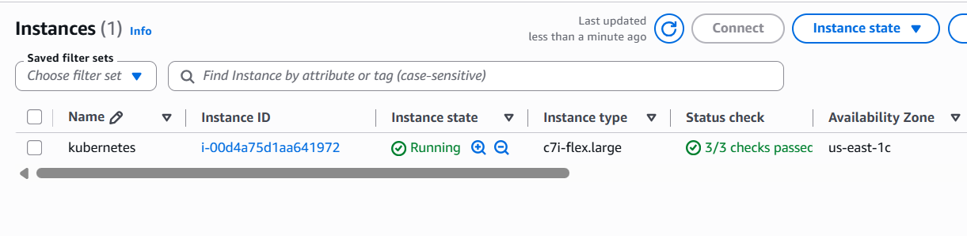

Then connect to instance and update server using following commands.
sudo apt update
sudo apt upgrade –y
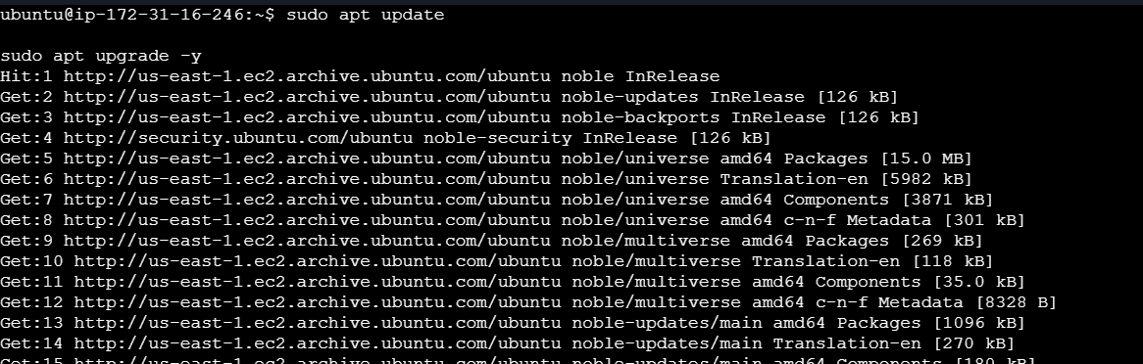

Step 2 — Install Docker
sudo apt install docker.io -y
Enable Docker using following commands
sudo systemctl enable docker

sudo systemctl start docker
Now verify using following commands
docker –version

Step 3 — Install Kubernetes Components
Install required dependencies
sudo apt install apt-transport-https curl –y

Now download Kubernetes key and add repository
curl -fsSL https://pkgs.k8s.io/core:/stable:/v1.32/deb/Release.key | sudo gpg --dearmor -o /etc/apt/keyrings/kubernetes-apt-keyring.gpg

echo 'deb [signed-by=/etc/apt/keyrings/kubernetes-apt-keyring.gpg] \
https://pkgs.k8s.io/core:/stable:/v1.32/deb/ /' | \
sudo tee /etc/apt/sources.list.d/kubernetes.list
Install
sudo apt install kubeadm kubelet kubectl -y
Hold packages and verify
sudo apt-mark hold kubelet kubeadm kubectl
kubectl version --client

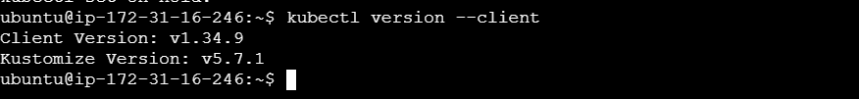

Step 4 — Install Container Runtime (containerd)
sudo apt install containerd -y
Now create config and Restart
sudo mkdir -p /etc/containerd
containerd config default | sudo tee /etc/containerd/config.toml
sudo systemctl restart containerd

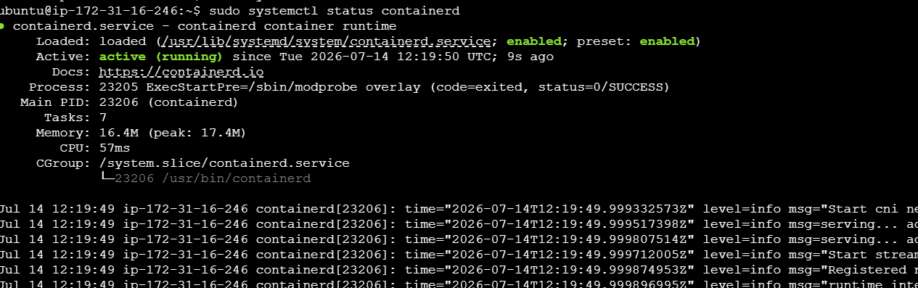

Step 5 — Initialize Cluster
sudo kubeadm init
This creates
- API Server
- Scheduler
- Controller Manager
- Etcd
At the end you'll see
mkdir -p $HOME/.kube

sudo cp /etc/kubernetes/admin.conf $HOME/.kube/config

sudo chown $(id -u):$(id -g) $HOME/.kube/config
Run them.

Step 6 — Install Network Plugin
Without networking Pods cannot communicate.
Install Calico
kubectl apply -f https://raw.githubusercontent.com/projectcalico/calico/v3.29.0/manifests/calico.yaml
Check
kubectl get pods -A
Wait until all pods are Running.
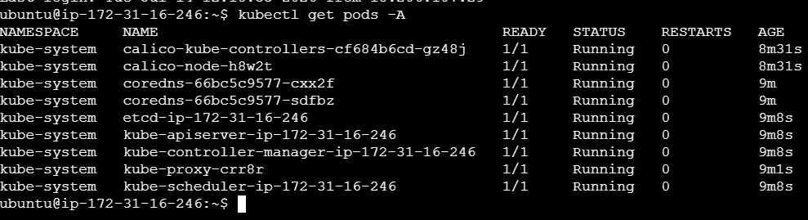

Step 7 — Allow Scheduling on Control Plane (Single Node Cluster)
Since we're using one EC2 instance:
kubectl taint nodes --all node-role.kubernetes.io/control-plane-

Step 8 — Install Helm
curl https://raw.githubusercontent.com/helm/helm/main/scripts/get-helm-3 | bash
Verify using
helm version

Step 9 — Create Namespace
kubectl create namespace monitoring
Namespaces separate resources logically.
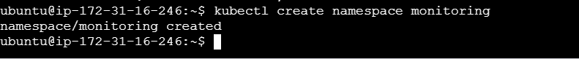

Step 10 — Install Prometheus
Add repo
helm repo add prometheus-community https://prometheus-community.github.io/helm-charts

helm repo update
Install
helm install prometheus prometheus-community/kube-prometheus-stack \
-n monitoring

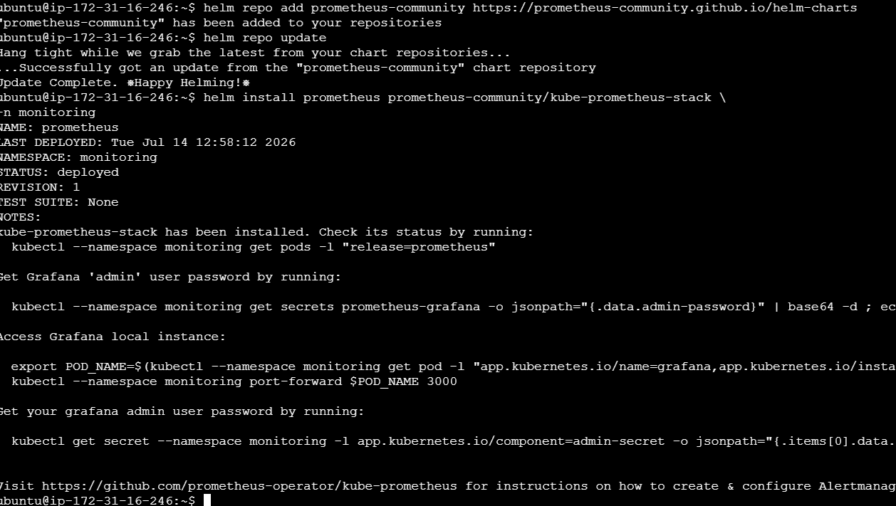
Check
kubectl get pods -n monitoring
You'll see
- Prometheus
- Alertmanager
- Grafana
- Node Exporter
- kube-state-metrics
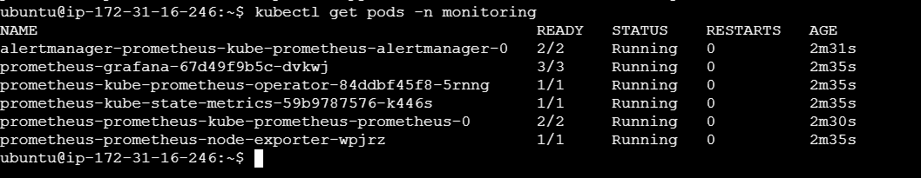

Step 11 — Get Grafana Password
kubectl get secret \
--namespace monitoring \
prometheus-grafana \
-o jsonpath="{.data.admin-password}" | base64 --decode

Step 12 — Port Forward Grafana
kubectl port-forward svc/prometheus-grafana \
3000:80 \-n monitoring
Open browser
http://Public-IP:3000

Step 13 — Create and build Docker Image
Example Dockerfile
FROM nginx

COPY index.html /usr/share/nginx/html
Build
docker build -t myapp:v1 .

Step 14 — Deploy Application
Create deployment.yaml and include following in it.

apiVersion: apps/v1
kind: Deployment

metadata:
name: myapp

spec:
replicas: 2

selector:
matchLabels:
app: myapp

template:

metadata:
labels:
app: myapp

spec:

containers:

- name: myapp

image: myapp:v1

ports:
- containerPort: 80
Now deploy using following command:
kubectl apply -f deployment.yaml

Step 15 — Create Service
Now create service.yaml and include following in it.
apiVersion: v1

kind: Service

metadata:

name: myapp-service

spec:

type: NodePort

selector:

app: myapp

ports:

- port: 80

targetPort: 80

nodePort: 30080
Then apply
kubectl apply -f service.yaml

Step 16 — Verify
Pods
kubectl get pods

Deployments
kubectl get deployments
Services
kubectl get svc
Nodes
kubectl get nodes

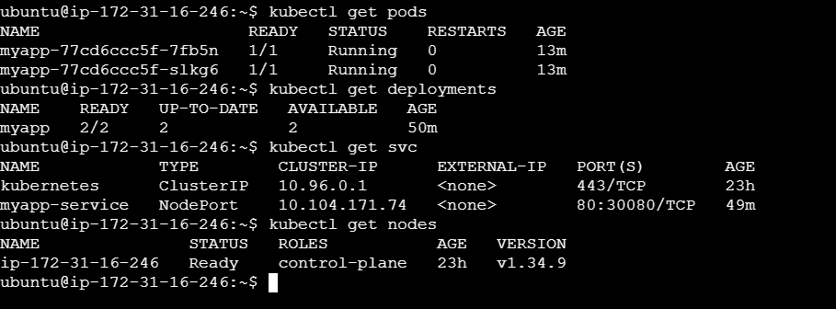

Step 17 — Open Application
http://Public-IP:30080
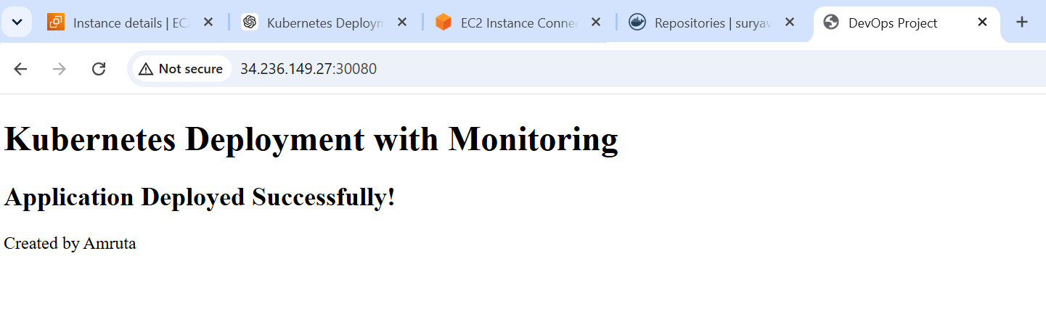
Step 18 –Open Prometheus
Prometheus collects (scrapes) these metrics at regular intervals (typically every 15 seconds).
Open:
http://public-ip:port
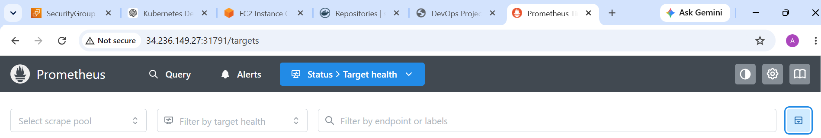
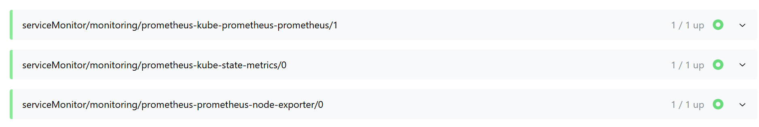
Following graph shows available RAM on the node.
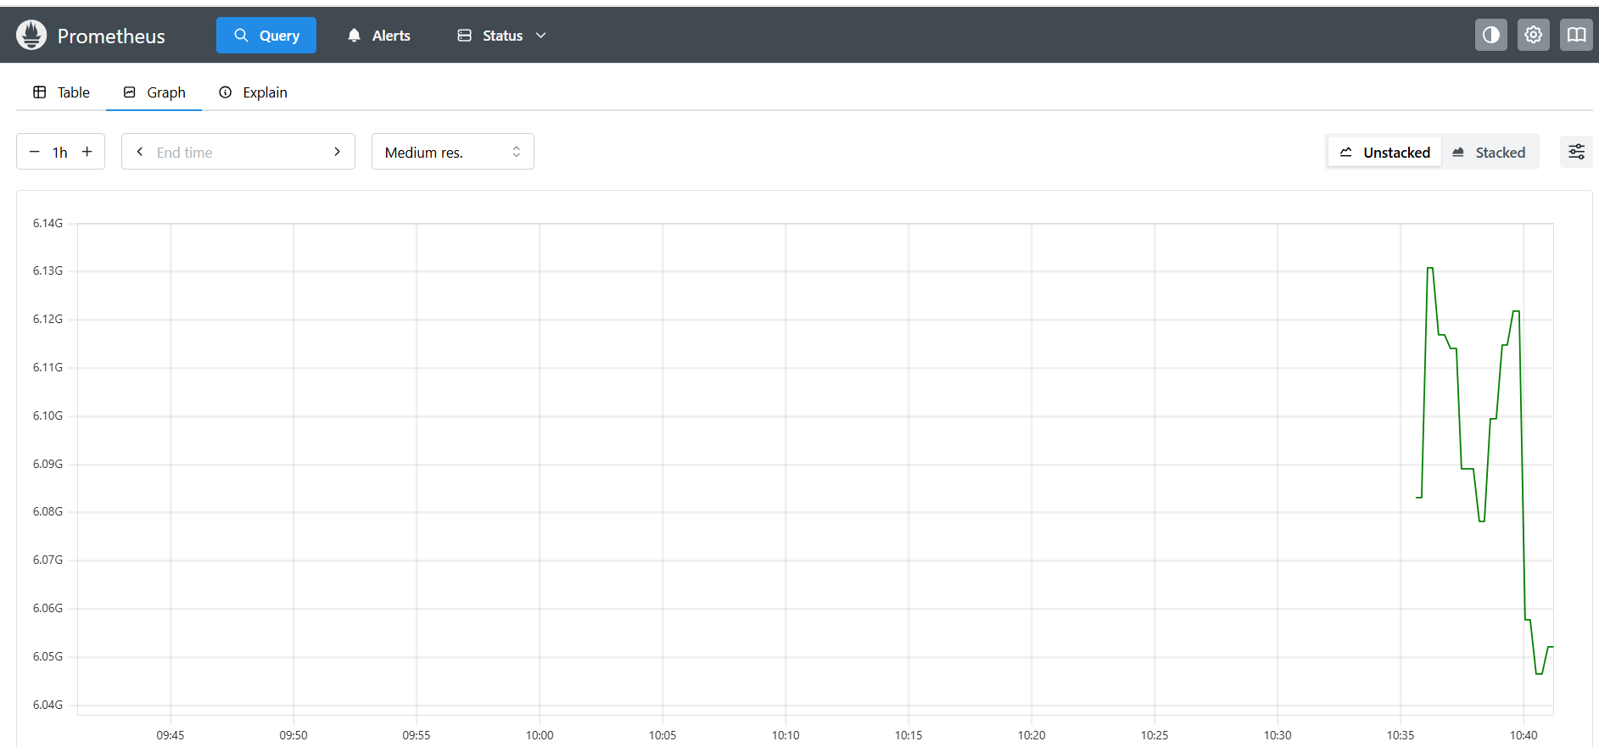
Following graph shows memory usage by containers.
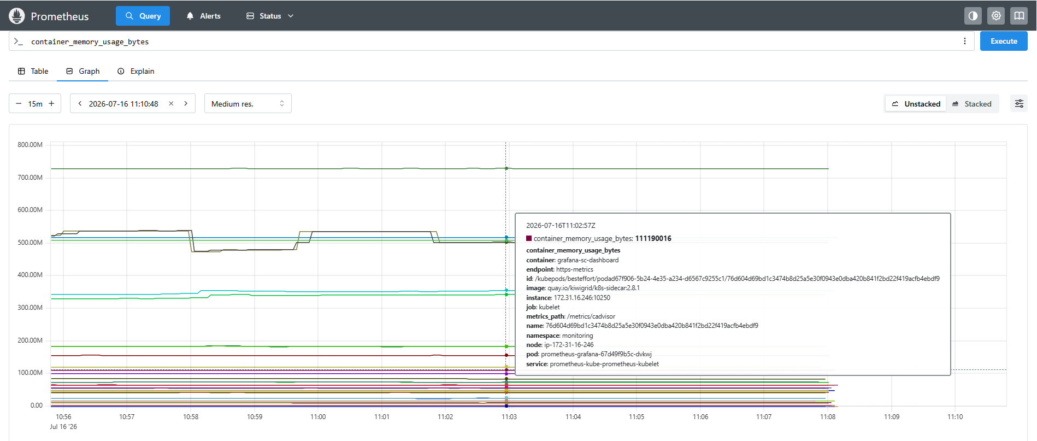
Following graph shows available disk space.
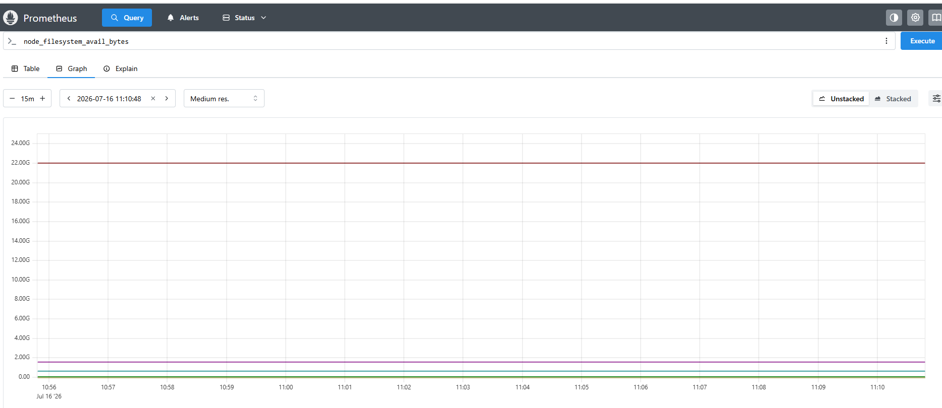

Following graph shows incoming network traffic.
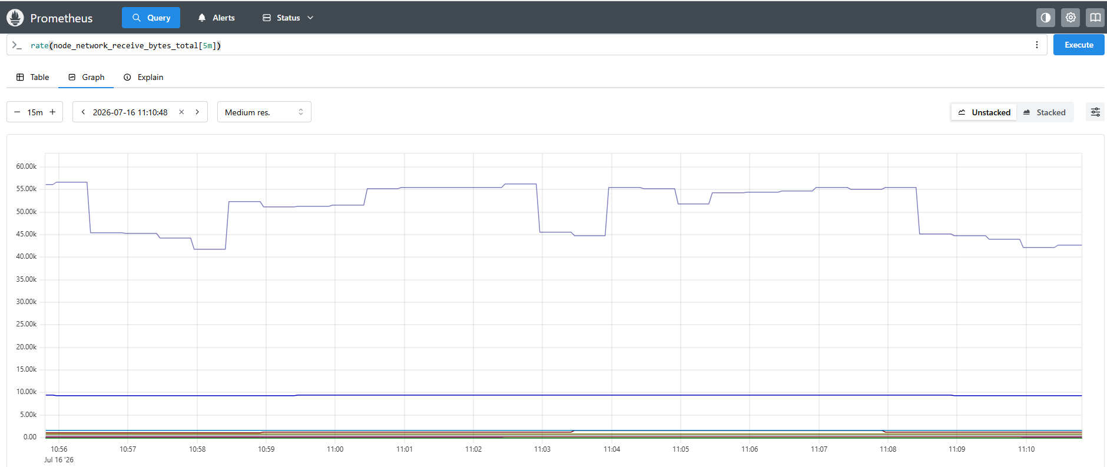
Step 19 – Open Grafana
Grafana reads the metrics from Prometheus and displays them as dashboards.
Open
http://public-ip:port

Open Dashboards
Go to: Dashboards
You'll find dashboards such as:
- Node Exporter / Nodes
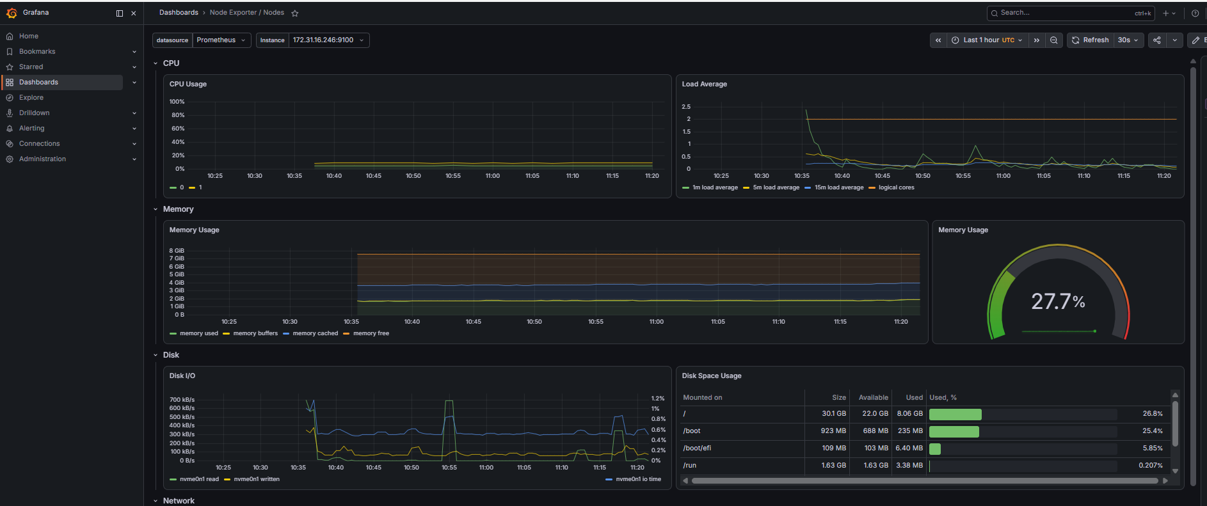

- Kubernetes Cluster
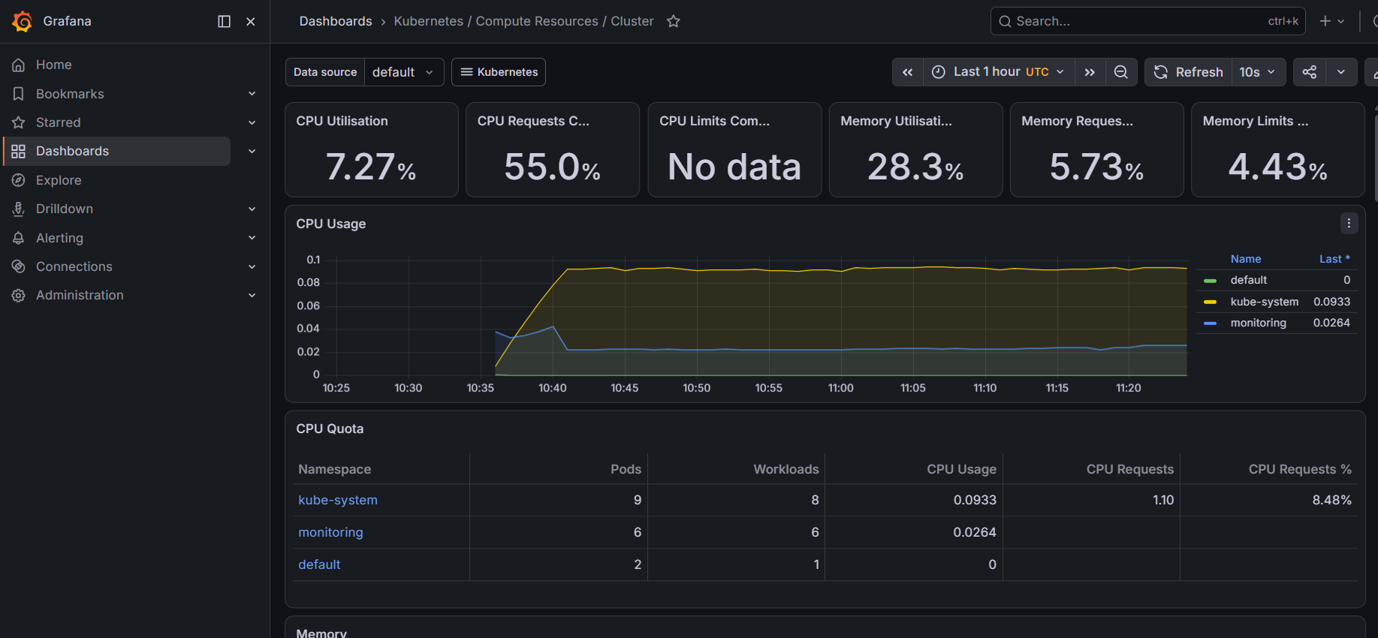
- Kubernetes Pods
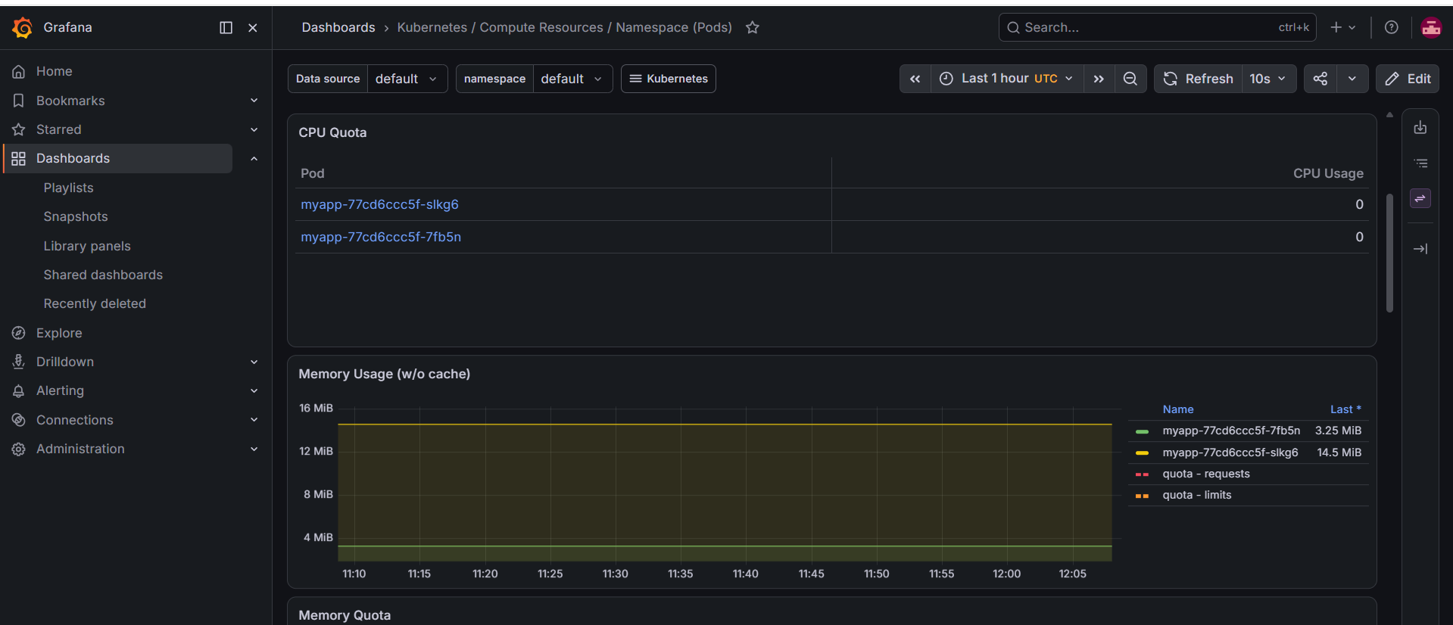
- Kubernetes / Compute Resources / Node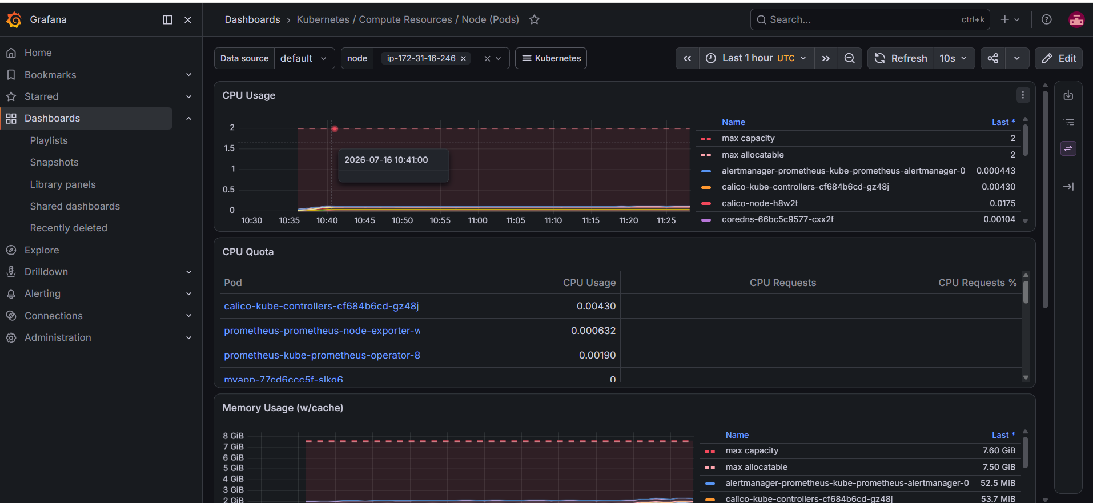
- Prometheus Overview
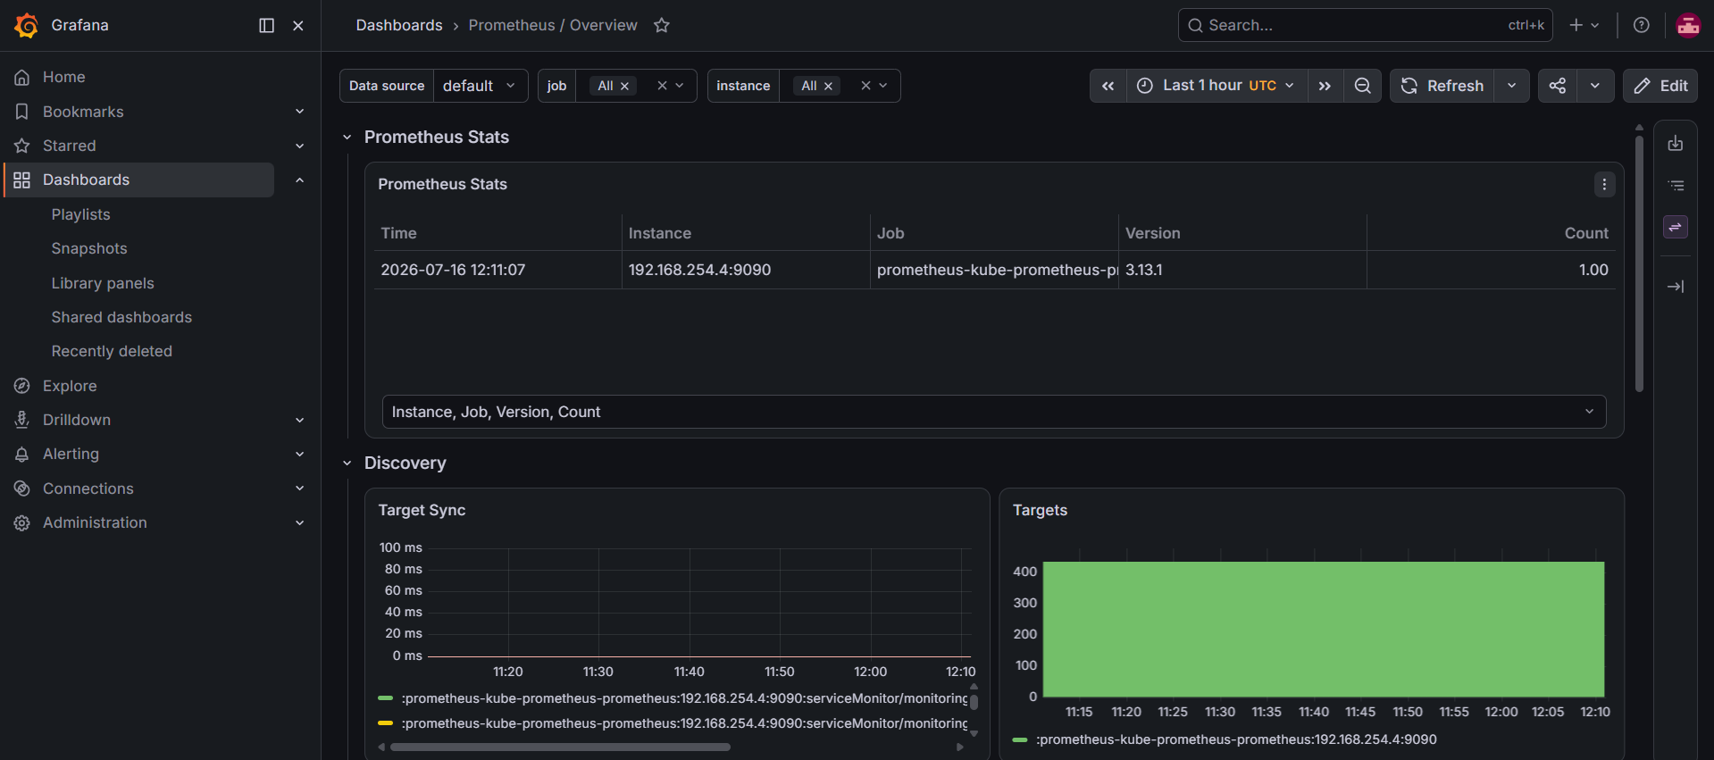
Troubleshooting

Issue -1:
- kubectl get nodes

NotReady
Solution
- sudo systemctl restart kubelet

Issue -2:
- Prometheus Target DOWN
Solution
- kubectl get pods -n monitoring
- kubectl logs

Issue -3:
- Grafana No Data
Solution
- Verify Prometheus datasource.

Issue-4:
- ImagePullBackOff
Solution
- docker push
- Update deployment image

Skills Learned

- AWS EC2

- Linux

- Docker

- Kubernetes

- Helm

- Prometheus

- Grafana

- Monitoring

- Git

- GitHub

- Troubleshooting

